Name: Fahad Pervez
Lab Assignment
Installing Kali Linux on VMware Workstation
A Step-by-Step Guide with Screenshots

Objective
The objective of this lab is to install Kali Linux as a virtual machine inside VMware Workstation (or VMware Player). By the end of this lab, we will be able to download Kali Linux ISO, create a new virtual machine in VMware, configure hardware settings, install the operating system, and log in successfully.

System Requirements
Component | Requirement
Processor | 64-bit Intel Core i3/i5/i7 or AMD equivalent
RAM | 4 GB minimum (8 GB recommended for smooth performance)
Storage | 30 GB free disk space minimum
Operating System | Windows 10/11 (64-bit) or Linux host
VMware Version | VMware Workstation Pro/Player 16 or later
Kali Linux ISO | Latest version from kali.org (e.g., kali-linux-2024.x-amd64.iso)
Internet | Required to download ISO and VMware tools

Steps
Step 1: Download Kali Linux ISO File
- Open your browser and go to the official Kali Linux website:
https://www.kali.org/get-kali/#kali-installer-images
- Under the Installer Images section, click on the 64-bit ISO download link.
- Wait for the download to complete. The file size is typically around 3–4 GB.
- Optionally verify the SHA256 checksum to ensure the file is not corrupted.
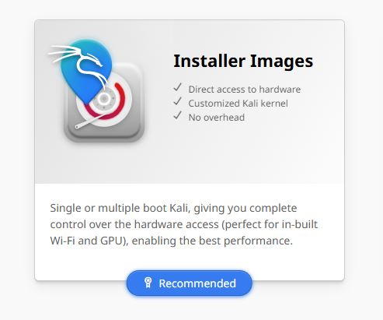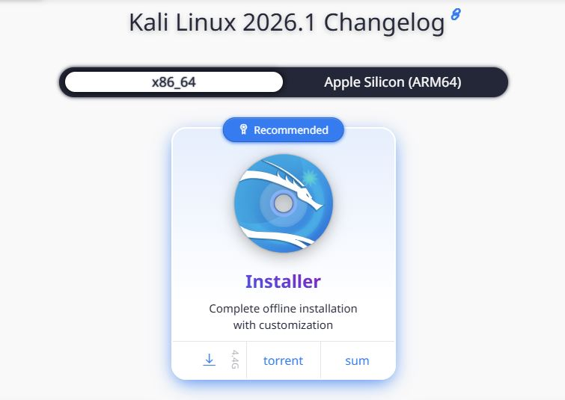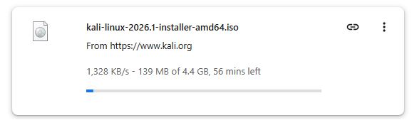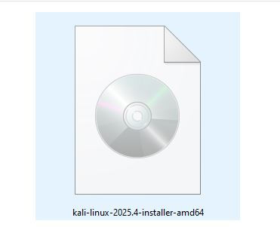
Step 2: Download and Install VMware Workstation
- Go to the VMware official website:
https://www.vmware.com/products/workstation-player/workstation-player-evaluation.html
- Download VMware Workstation Player (free for personal use) or VMware Workstation Pro (paid/trial).
- Run the downloaded installer (.exe on Windows).
- Follow the on-screen setup wizard: Accept license agreement → Choose installation path → Click Install.
- Restart your computer after installation if prompted.
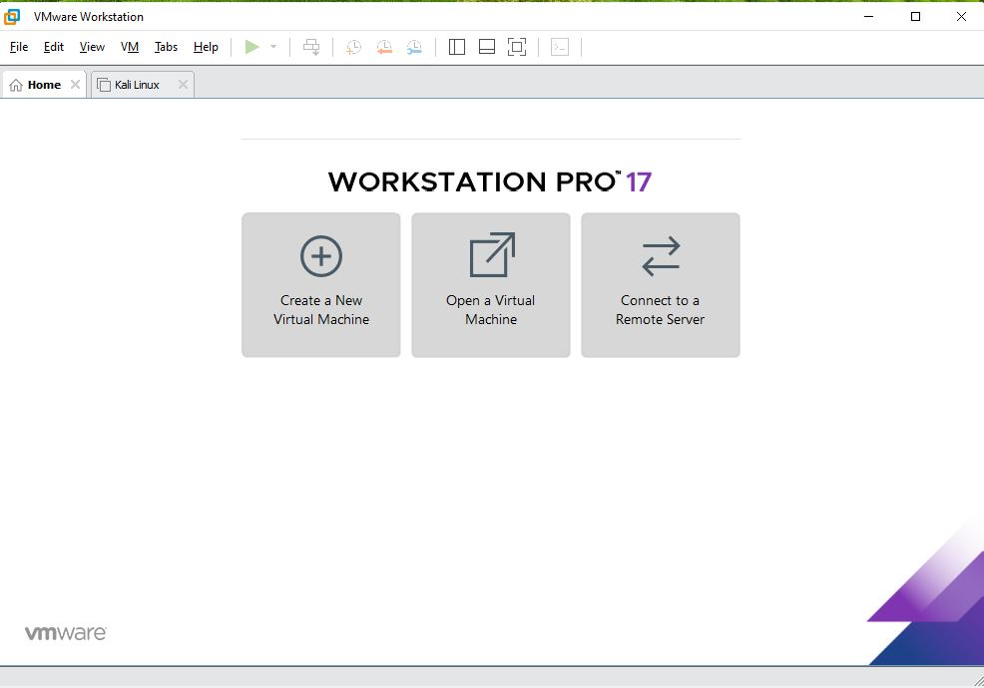
Step 3: Launch VMware and Create a New Virtual Machine
- Open VMware Workstation Player or Pro from the desktop shortcut or Start Menu.
- On the home screen, click on 'Create a New Virtual Machine'.
- The New Virtual Machine Wizard will open.
- Select 'Installer disc image file (iso)' and click Browse to locate the Kali Linux ISO you downloaded.
- VMware may detect it as 'Linux' automatically — click Next to continue.
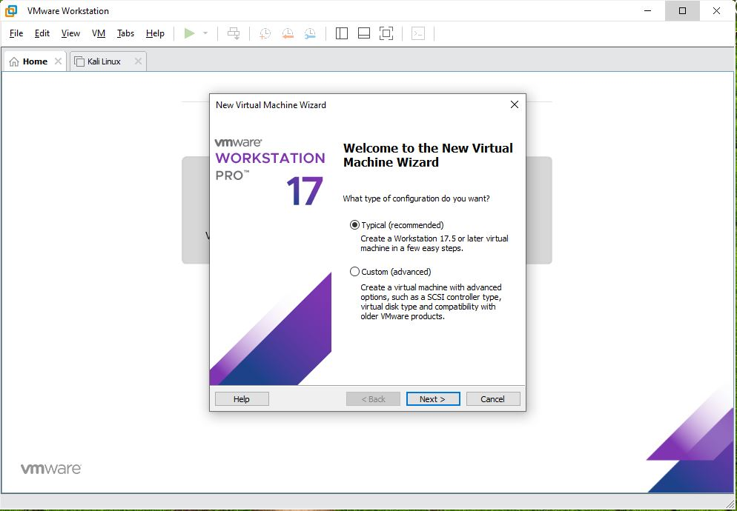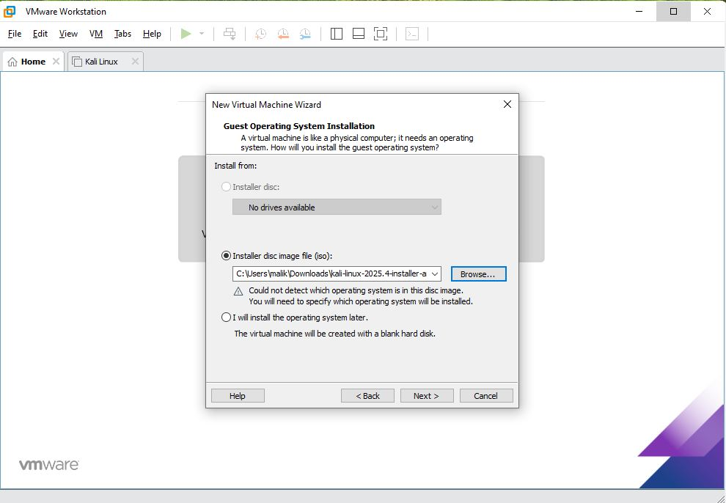

Step 4: Configure Virtual Machine Settings
- Guest Operating System: Select Linux, then from the Version dropdown choose 'Debian 11.x 64-bit' (Kali is based on Debian).
- Virtual Machine Name: Type a name (e.g., Kali-Linux-2024) and choose a folder to save the VM.
- Processor Configuration: Set Number of Processors to 1 and Number of cores per processor to 2 (or more if your CPU supports it).
- Memory (RAM): Allocate at least 4096 MB (4 GB). 8 GB is recommended for best performance.
- Network Type: Select 'Use Network Address Translation (NAT)' so the VM can share the host internet.
- Disk: Create a new virtual disk with at least 30 GB. Choose 'Store virtual disk as a single file' for simplicity.
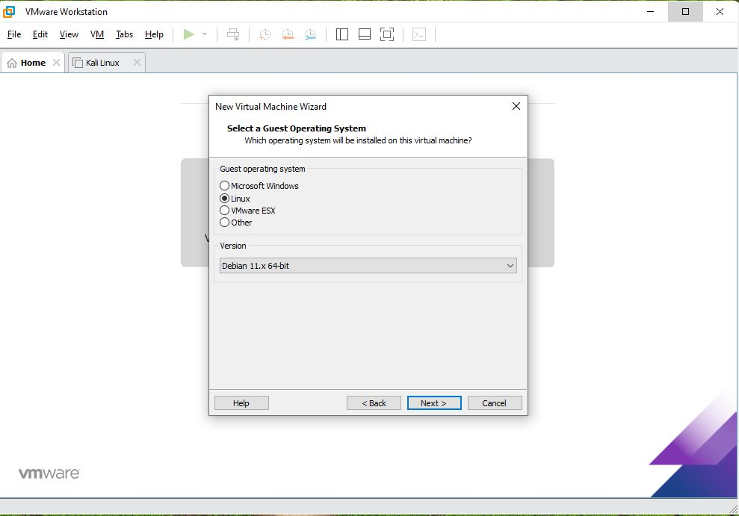
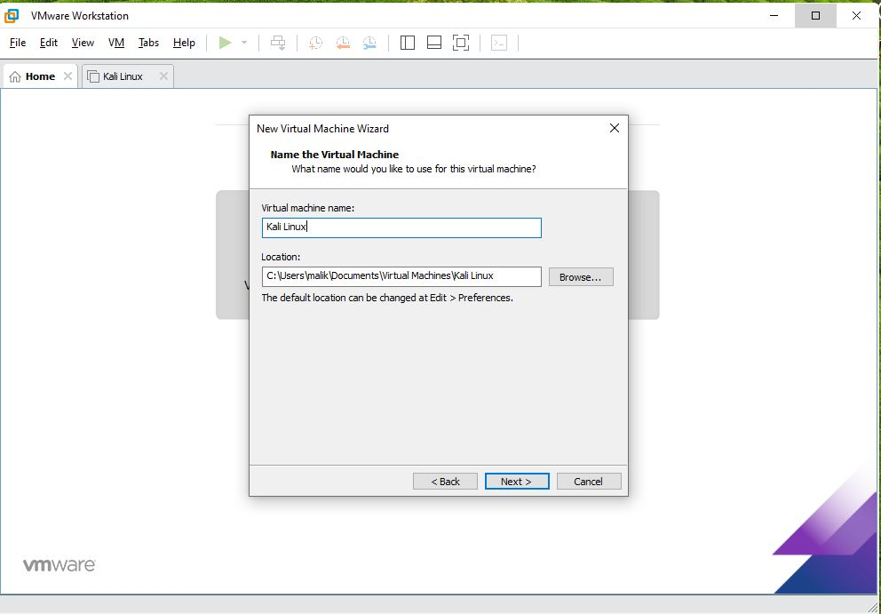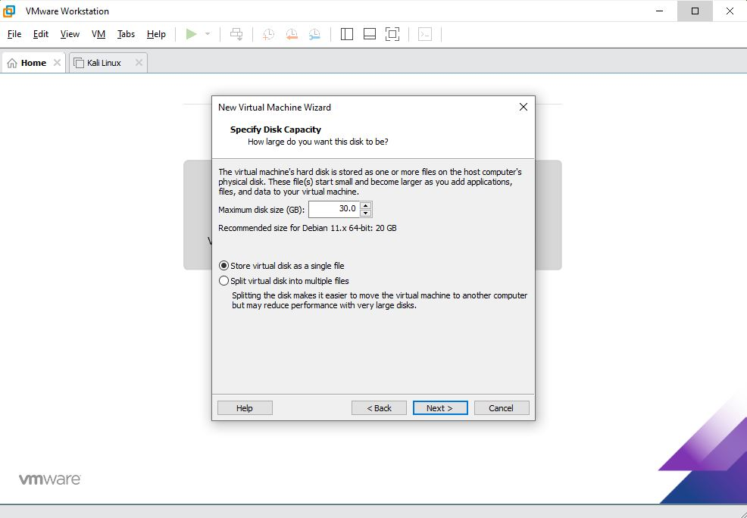
Step 5: Review Summary and Finish
- Review the summary page showing all VM settings.
- Verify: ISO path, OS type, RAM, and Disk size are correct.
- Click 'Finish' to create the virtual machine.
- The new VM will appear in the VMware library on the left sidebar.
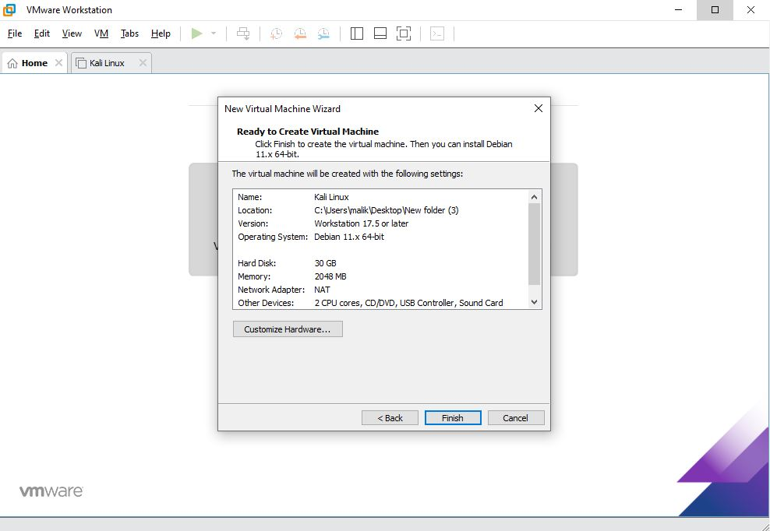
Step 6: Power On the Virtual Machine
- Select your newly created Kali Linux VM from the list.
- Click the green 'Power On' button (or press Ctrl+B).
- The VM will start booting from the ISO image.
- A splash screen with the Kali Linux logo will appear.

Note: If VMware asks to install VMware Tools, click 'Remind Me Later' — you can do this after installation.
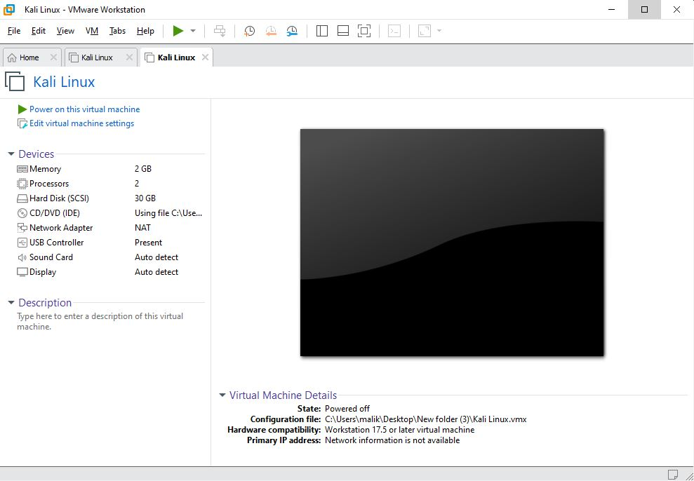
Step 7: Start the Kali Linux Graphical Installation
- From the Kali boot menu, use the arrow keys to select 'Graphical Install' and press Enter.
- Language: Select your preferred language (e.g., English) and click Continue.
- Location: Choose your country or region and click Continue.
- Keyboard: Select your keyboard layout (e.g., American English) and click Continue.
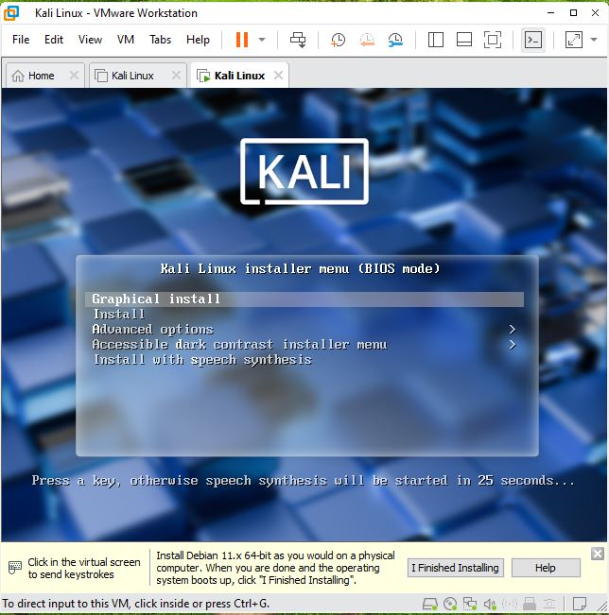
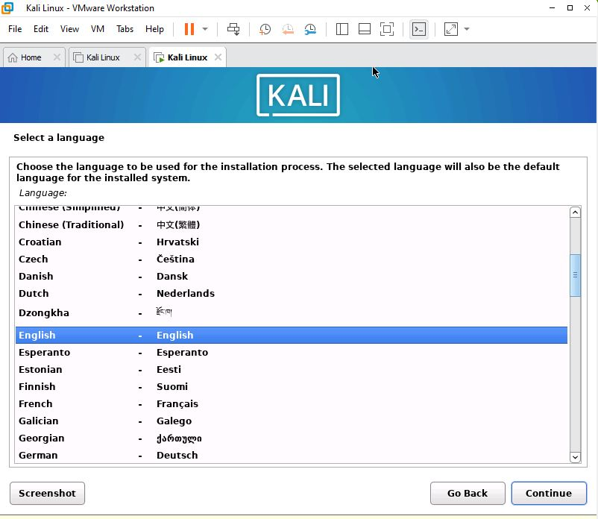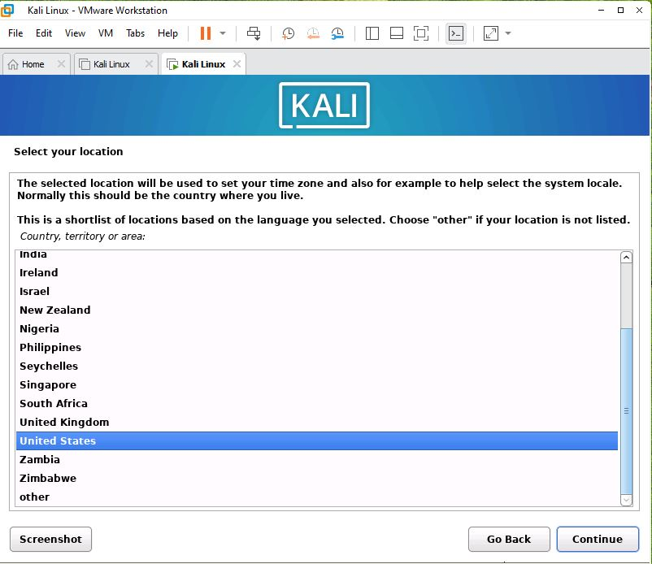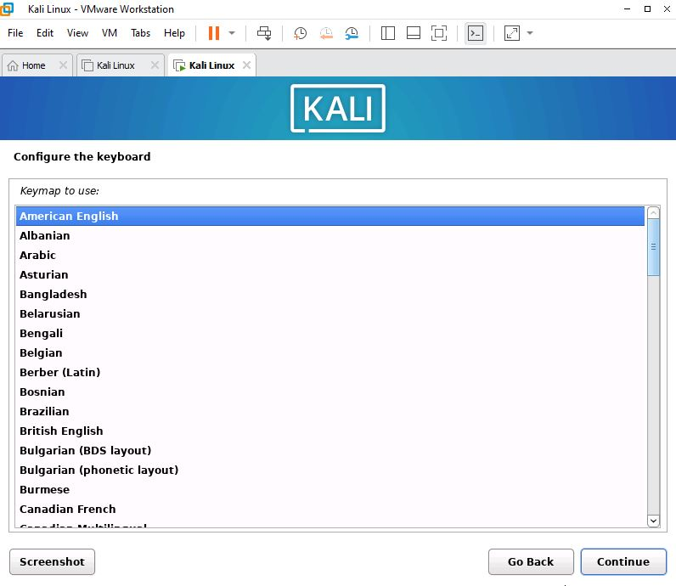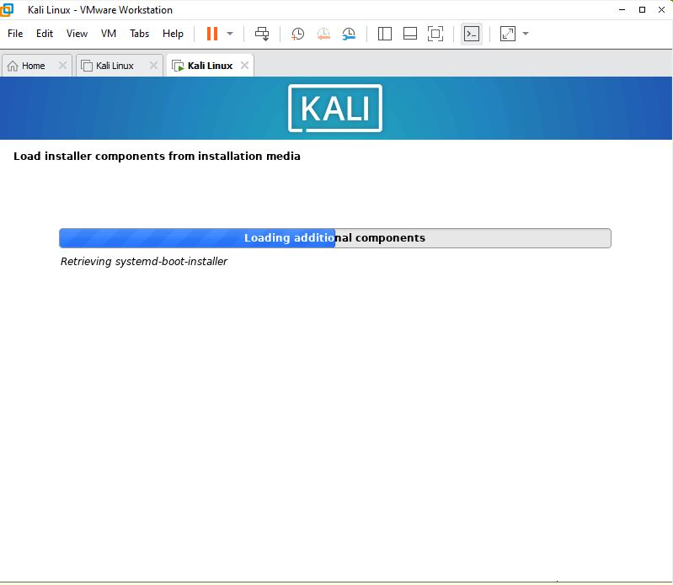
Step 8: Configure Hostname and Network
- Hostname: Enter a hostname for your machine (e.g., kali) and click Continue.
- Domain Name: You may leave this blank or type 'local' and click Continue.
- The installer will automatically configure the network via DHCP (using VMware NAT).
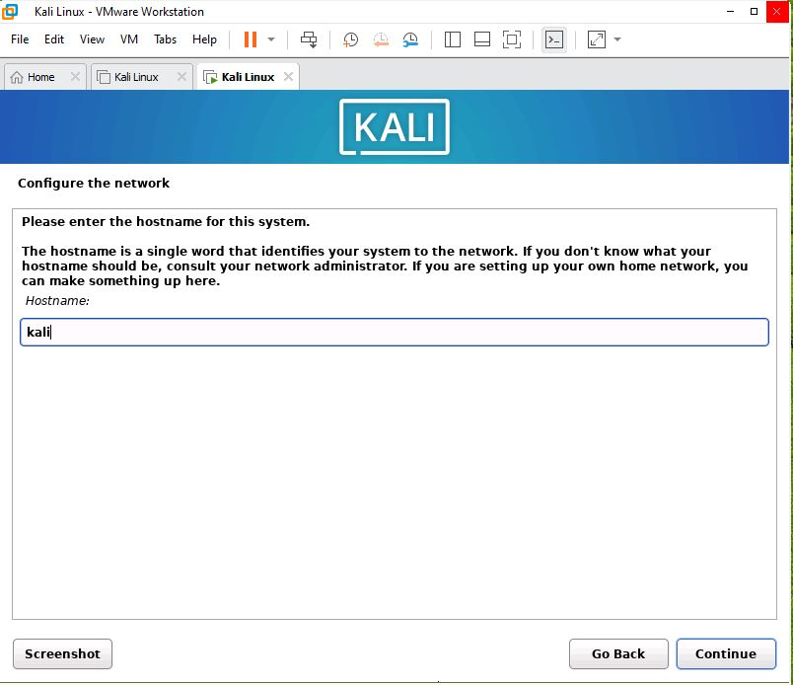
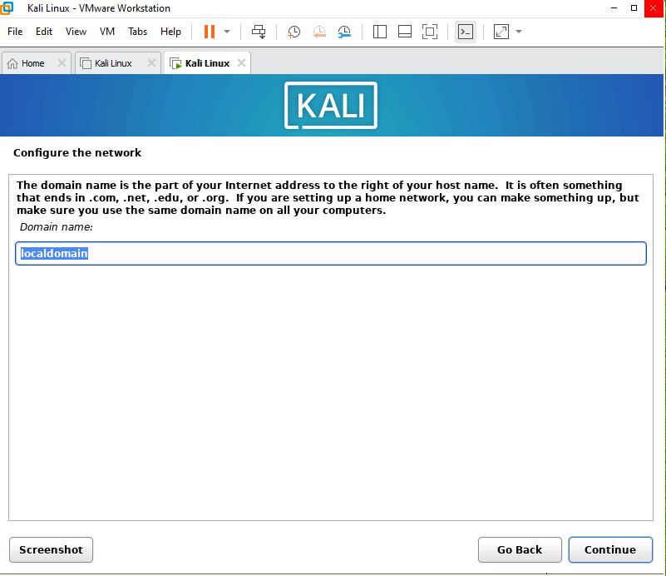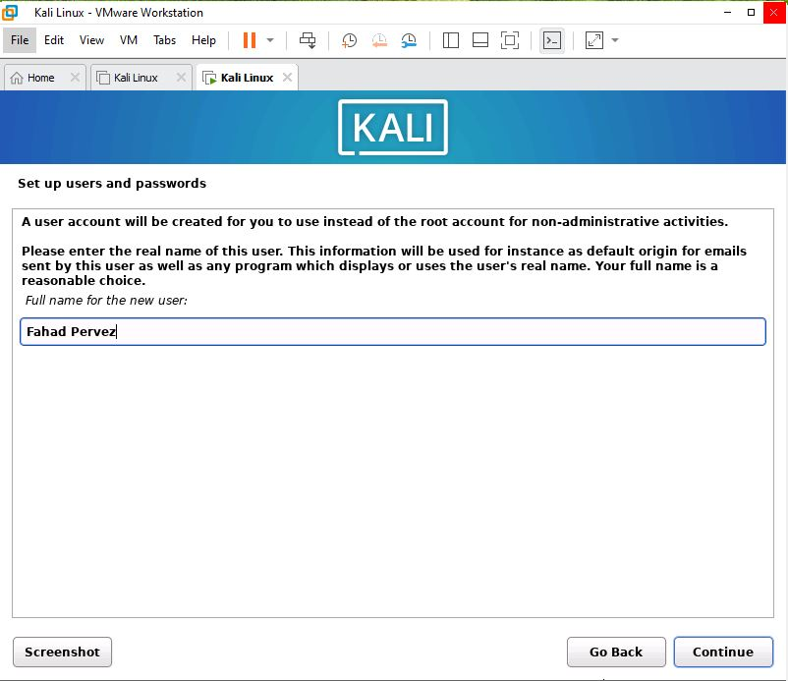
Step 9: Set Up User Account and Password
- Root Password: Enter a strong password for the root account and confirm it. Click Continue.
- Full Name: Enter your full name for the new user account.
- Username: Enter a username (e.g., student) and click Continue.
- User Password: Set and confirm a password for this user account. Click Continue.

Important: Use a strong password containing uppercase, lowercase, numbers, and symbols. You will need this to log in.
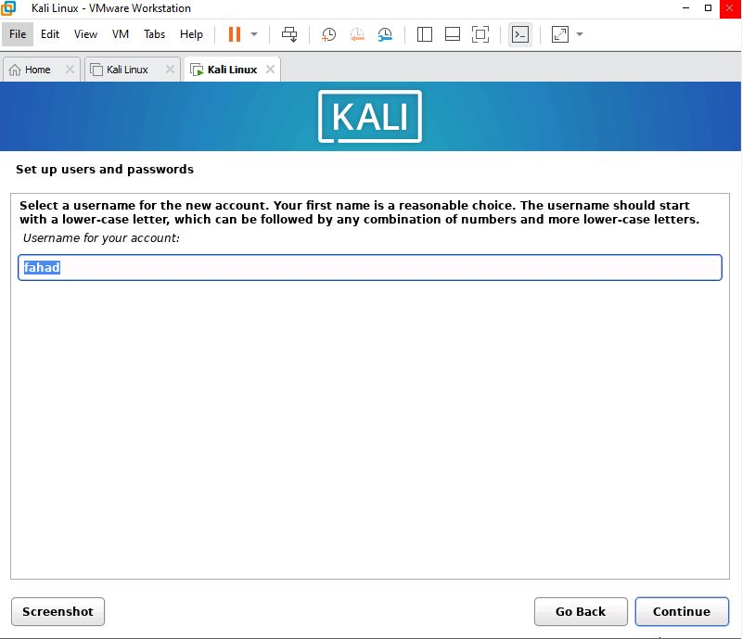
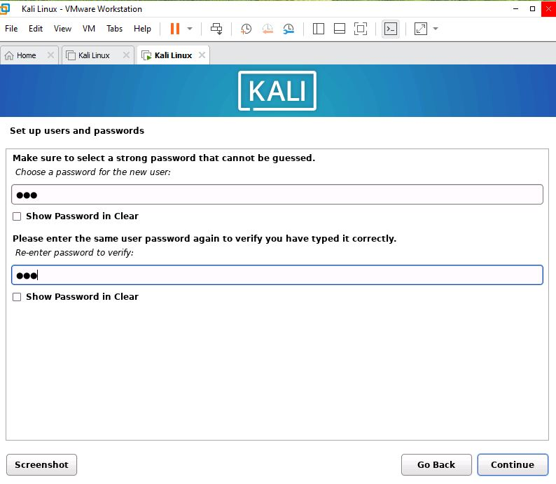
Step 10: Partition the Disk
- Partitioning Method: Select 'Guided – use entire disk' for the simplest setup.
- Select Disk: Choose the virtual disk you created (e.g., VMware Virtual S, ~30 GB).
- Partitioning Scheme: Select 'All files in one partition (recommended for new users)'.
- Review the proposed partition layout and click 'Finish partitioning and write changes to disk'.
- Confirm by selecting 'Yes' when asked to write changes, then click Continue.
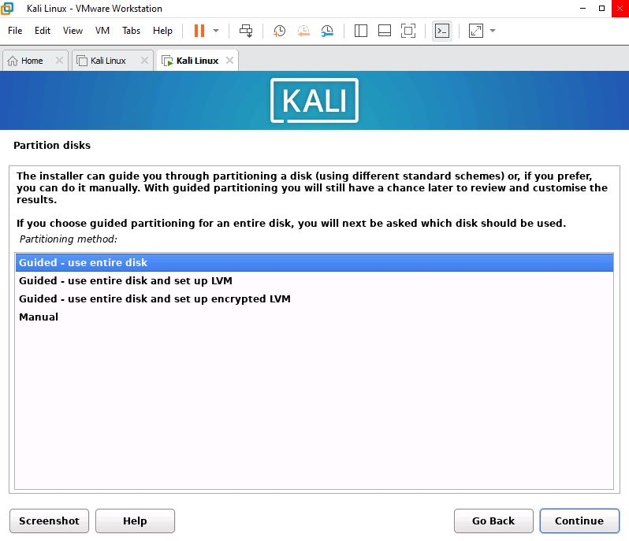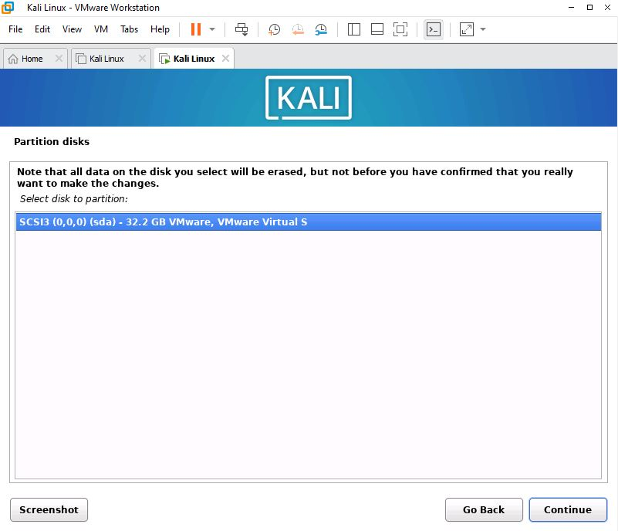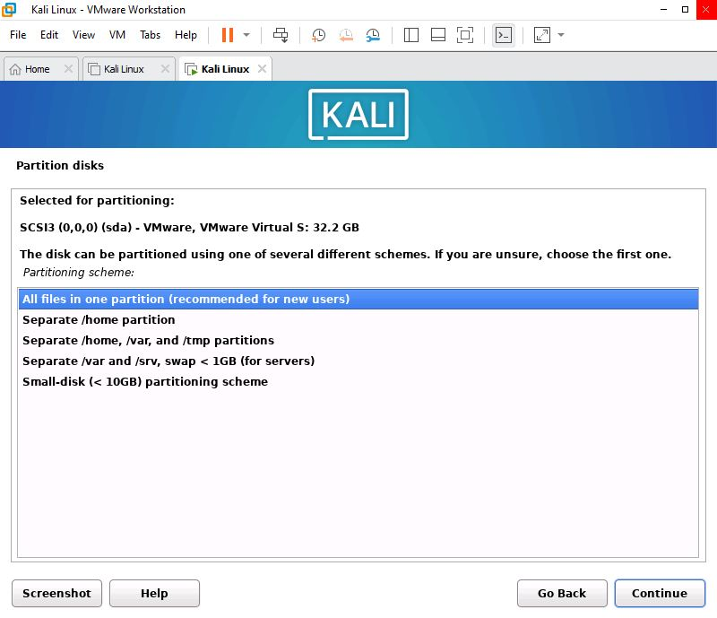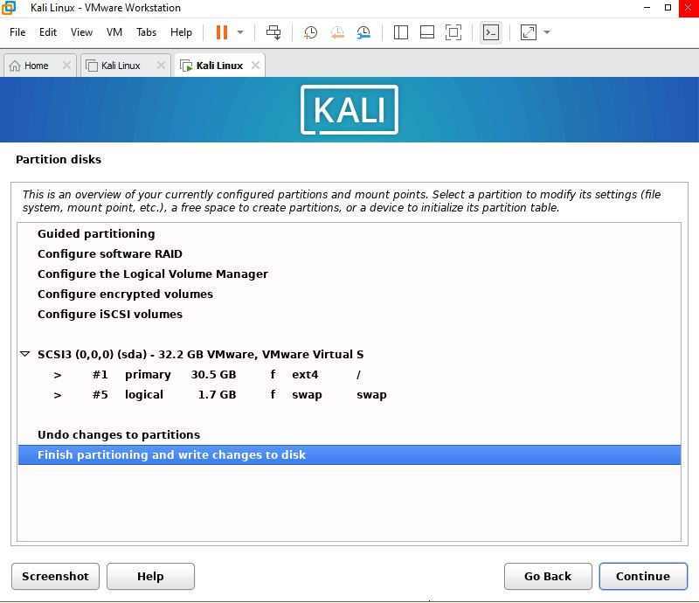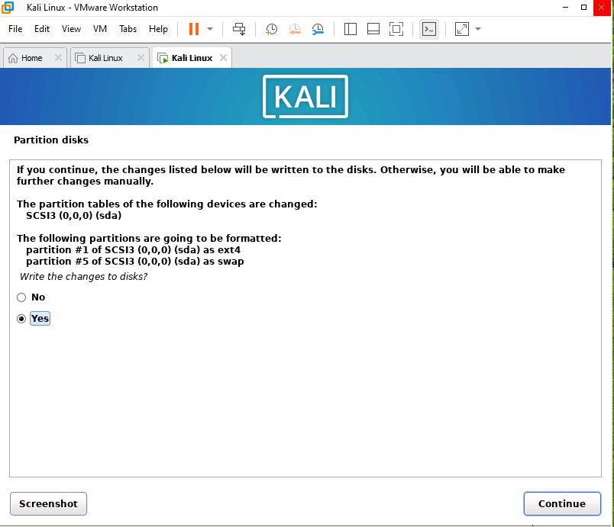
Step 11: Install the Base System
- The installer will now copy and install files. This process may take 10–20 minutes depending on your hardware.
- A progress bar will show the installation status. Do not close VMware during this step.

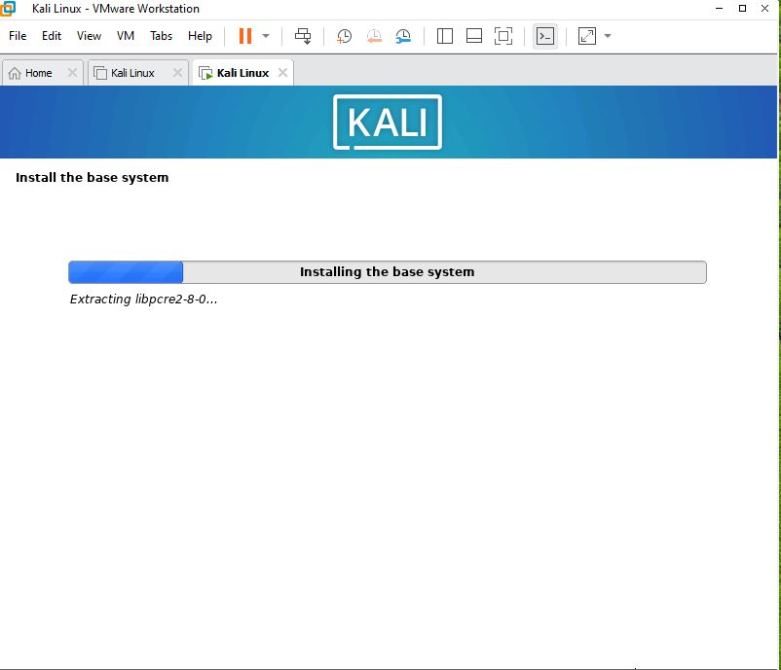
Step 12: Configure the Package Manager (Software Mirror)
- Network Mirror: Select 'Yes' to use an online mirror for additional packages.
- HTTP Proxy: Leave blank if you have a direct internet connection, then click Continue.
- The installer will configure the package manager automatically.
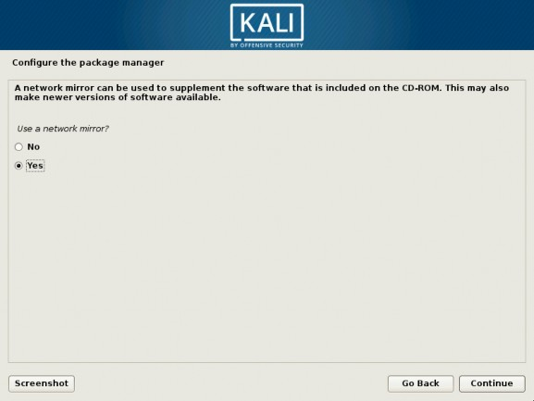

Step 13: Select Software (Desktop Environment)
- Software Selection: A list of software options will appear.
- By default, 'Kali desktop environment' and 'GNOME' (or XFCE) are selected.
- Also ensure 'top 10' tools or 'default' tools are checked for a standard Kali setup.
- Click Continue to begin software installation (this may take 15–30 minutes).
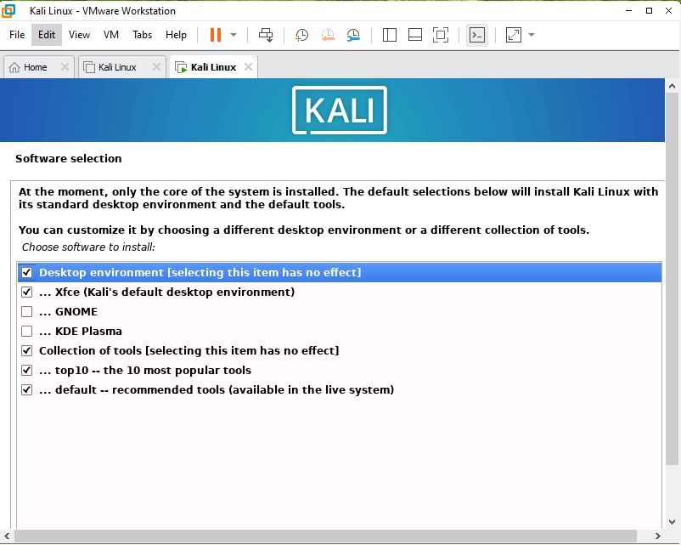

Step 14: Install the GRUB Bootloader
- Install GRUB: Select 'Yes' to install the GRUB bootloader to the master boot record.
- Device: Select the virtual hard disk (e.g., /dev/sda) and click Continue.
- GRUB allows the VM to boot Kali Linux after the ISO is ejected.
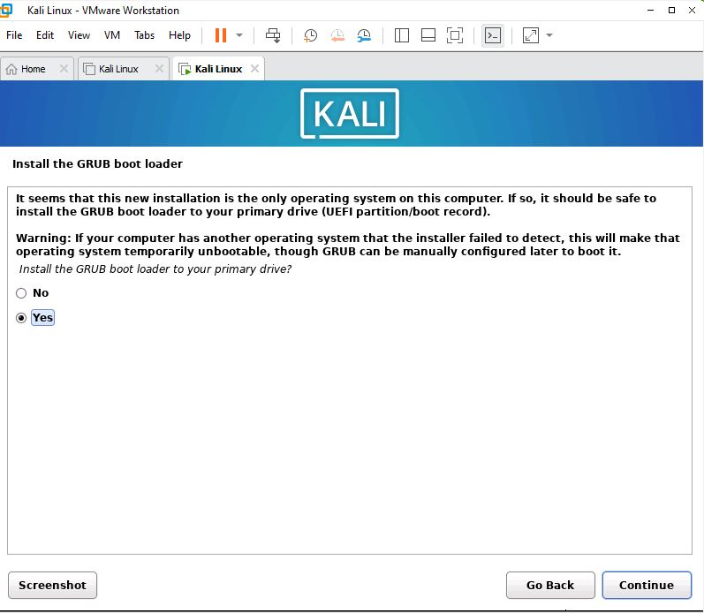
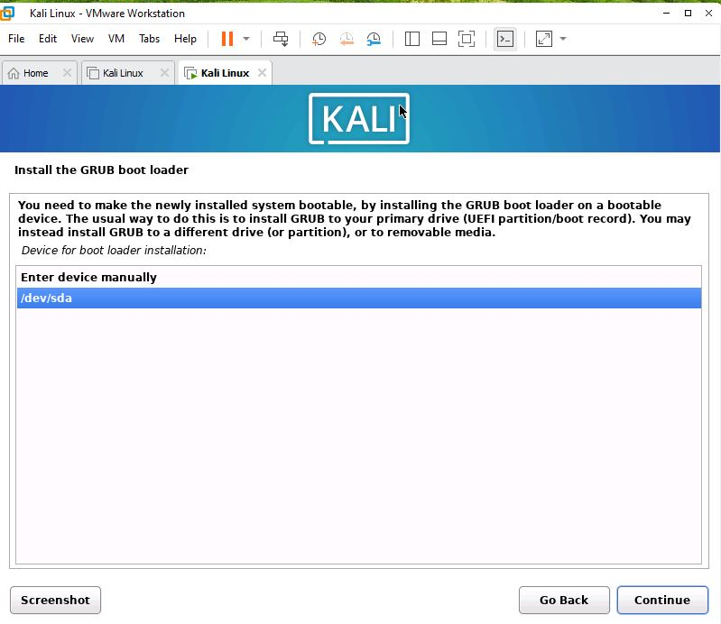
Step 15: Complete Installation and Reboot
- The installer will display an 'Installation Complete' message.
- Click Continue to reboot the virtual machine.
- VMware will automatically eject the ISO and restart from the installed system.
- The GRUB bootloader will appear briefly, then Kali Linux will begin loading.
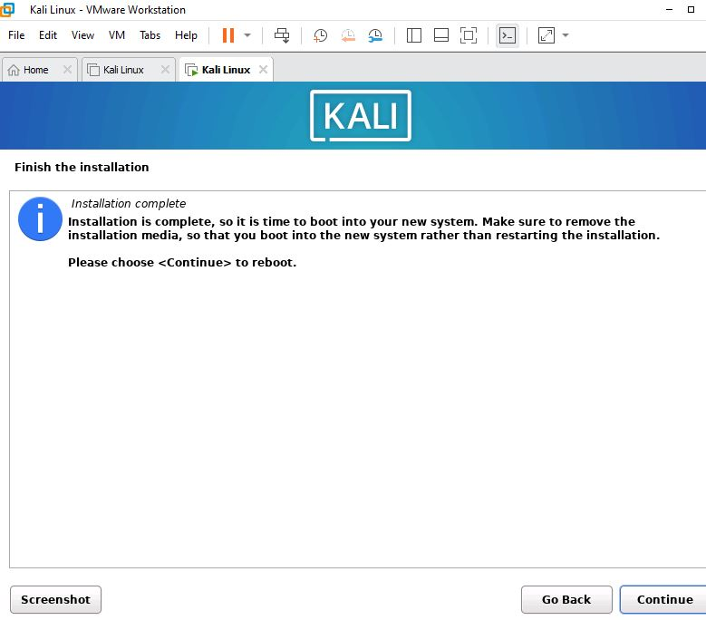
Step 16: Log In to Kali Linux
- The Kali Linux login screen (GDM/LightDM) will appear.
- Enter the username and password you created during installation.
- Click 'Log In' or press Enter.
- The Kali Linux desktop environment (GNOME or XFCE) will load successfully.
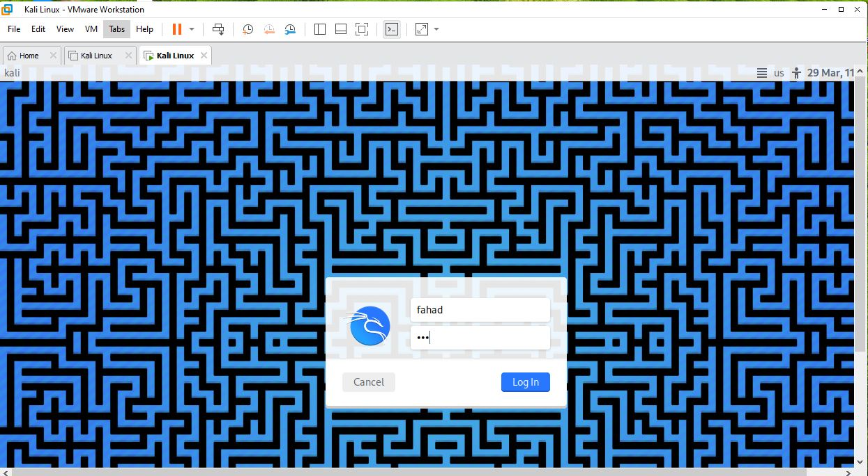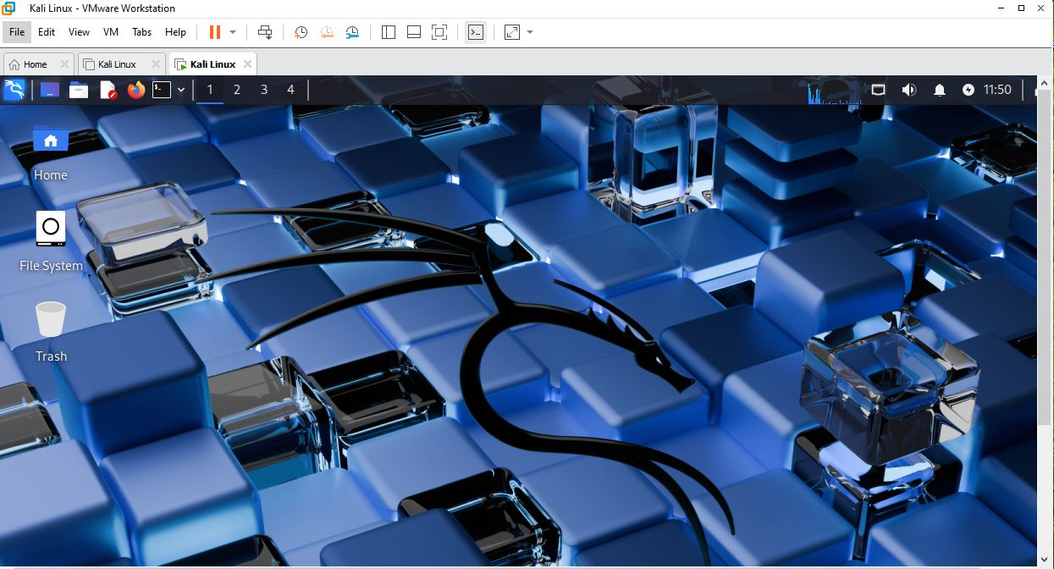
Step 17: Install VMware Tools (Optional but Recommended)
- In VMware menu, click 'VM' > 'Install VMware Tools'.
- Open a Terminal in Kali Linux (right-click desktop > Open Terminal).
- Run the following commands:
sudo apt update && sudo apt install -y open-vm-tools open-vm-tools-desktop
- After installation, reboot the VM. VMware Tools enables shared clipboard, drag-and-drop, and auto screen resizing.
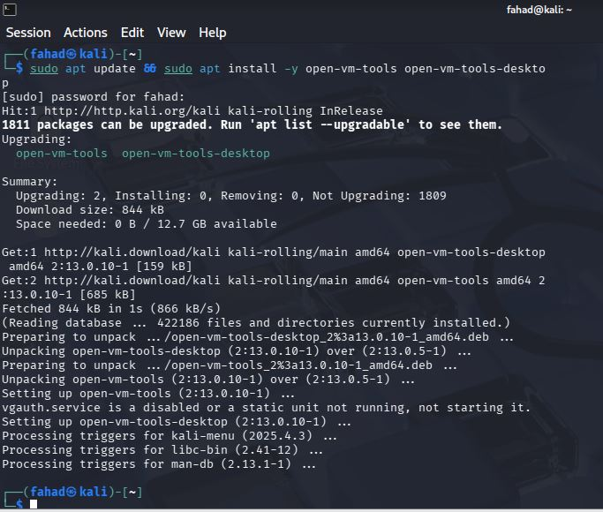

Result
Kali Linux has been successfully installed as a virtual machine inside VMware Workstation. The VM boots into the Kali Linux desktop environment with all default penetration testing tools pre-installed. The student can now use Kali Linux in an isolated virtual environment for ethical hacking, cybersecurity labs, and practice — without affecting the host operating system.

✔ Success: The installation is complete when you can log into the Kali Linux desktop and open a terminal successfully.

Common Issues & Troubleshooting
- VM won't boot from ISO: Verify the ISO path in VM Settings > CD/DVD > Use ISO Image File.
- Black screen after boot: Enable 3D acceleration in VM Settings > Display or disable it if already on.
- Slow performance: Increase RAM or CPU cores in VM Settings, and install VMware Tools.
- No internet in VM: Ensure network adapter is set to NAT in VM Settings > Network Adapter.
- GRUB not found after install: Boot from ISO again and re-install GRUB to /dev/sda.

